**DAY 8 TASK**

**WRITE A “PERSON” CLASS TO HOLD ALL THE DETAILS**

class person{

    constructor(name,age,location,company){

        this.name=name;

        this.age=age;

        this.location=location;

        this.company=company;

    }

    getdetails()

    {

       return'NAME:${this.name}.AGE:${this.age}.LOCATION:${this.location}.COMPANY:${this.company}';

    }

}

let person1 = new person("praveen",25,'coimbatore','TCS');

person1.getdetails();

console.log(person1);

let person2 = new person("dinesh",25,'chennai','TCS');

person2.getdetails();

console.log(person2);

let person3 = new person("navin",25,'bangalore','flipkart');

person3.getdetails();

console.log(person3);

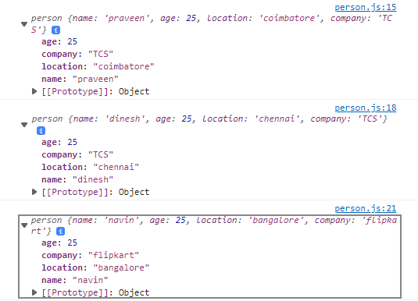

**WRITE A CLASS TO CALCULATE UBER PRICE**

class uber{

    constructor(name,pickup,drop,km){

        let price=km*20;

        this.name=name;

        this.pickup=pickup;

        this.drop=drop;

        this.km=km;

        this.price=price;

    }

    getdetails()

    {

        return'Name:${name}.Pickup:${pickup}.Drop:${drop}.Km:${km}.Price:${price}';

    }

}

let passenger1 = new uber('praveen','velachery','airport',9);

console.log(passenger1);

let passenger2 = new uber('kishore','central','marina',6);

console.log(passenger2);

